Find Your Next Job Now
series

Emotions and HOW to Job
Week 8 of 9
April 6, 2023

After this session, you'll be able to:
- Be kinder to yourself via your emotions
- Plan for the work you want
- Have an understanding of how someone recently found a job (We have a guest for ten minutes)

Announce: 1) Slack/Mighty networks channel? 2) Next Monday.

Senia Maymin, PhD (LinkedIn)
senia@senia.com
Jobsearch mailing list: www.jobsearch2023.com

Table of Contents

Where We Are 3
What We’ve Covered So Far 4
Emotions and HOW to Job 6
1) Be kinder to yourself via your emotions 6
2) Plan for the work you want 8
3) Have an understanding of how someone recently found a job 9
YOUR ACTIONS BETWEEN TODAY AND NEXT WEEK 10
A request from me to you 10
How to Get More Info on the #JobSearch2023 Series 12
How to get on the mailing list - we send ALL updates here 12
Are the sessions recorded? Yes 12
Most sessions have a workbook 12

Where We Are
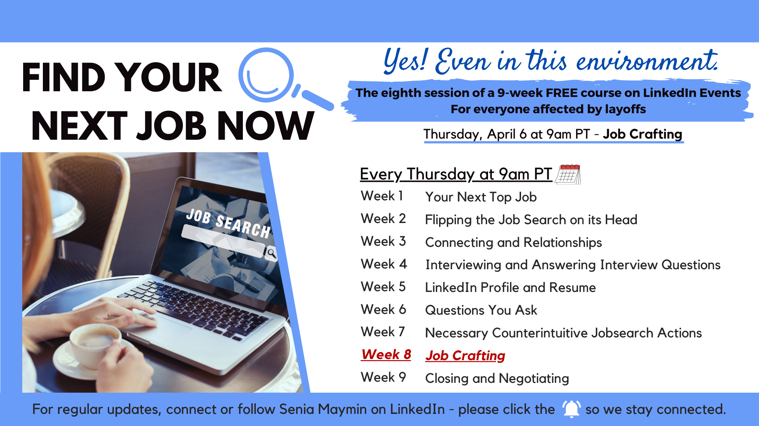

What We’ve Covered So Far

Session 1 - 3 Tools
- Co-create more effective interviews (opening question; closing question)
- Demonstrate collaboration and confidence implicitly (consultant mindset)
- Decrease the feeling of stress
- Reach out to people
Session 2 - Flipping the Job Search on Its Head
- Take on a consultant mindset when looking for a job
- Find specific people to reach out to
- Really explore your next role
  - Want - Wish - Boundaries
  - GPS for the role (Location, Industry, Role)

Session 3 - Connecting
- How to position WHO you are
- How to offer what THE PERSON may be interested in: “For ____________, I ____________ to get these results ____________________ by ____________.”
- How to NOT LOOK for a job while looking for a job
- How to reach out via email

Session 4 - How to Interview Superbly Well
- What questions you will get asked
- How to answer these questions. SARI Stories: “The situation was ____________ The three actions I took were ____________ The result was ____________ (include metrics if you can) …. By the way, an interesting thing that came out of this was ____________”
- The “Tell Me about Yourself” question

Session 5 - Resume and LinkedIn Profile
- What HR Looks For in Your Resume and LinkedIn Profile
- How to Make Your Resume Phenomenal
- How to Dazzle and Engage Recruiters with Your LinkedIn Profile

Session 6 - Questions for YOU as the Job Candidate to Ask
- Why it’s so important to have questions prepared
- Having these types of questions for interviews
  - (Opening Question) For YOU, what is most important about how the person in this role will help you with your work?
  - "Imagine…"
  - Broad → Detailed
  - FUN questions (Culture, Surprised, Not Asking)
  - (Closing Question) Fit and Hesitation question

Session 7 - Counterintuitive Actions in the Job Search
- Have an 11-page Prep Document (for each role you interview for)
- Use Your Strengths in the Job Search
- Lightning Round:
  - Have tools for your job search
  - Have an anti-awkwardness mechanism: Sportscasting

Emotions and HOW to Job

1) Be kinder to yourself via your emotions

Why am I talking about this with you in week 8?

Because I’m seeing that it’s rough out there:
- “The market is getting tougher/tighter and it's hard not to internalize/personalize it. How should I prioritize my actions?”
- “I've been at this for a number of months. What should I do differently?”
- “It's hard to stay motivated without seeing results.”

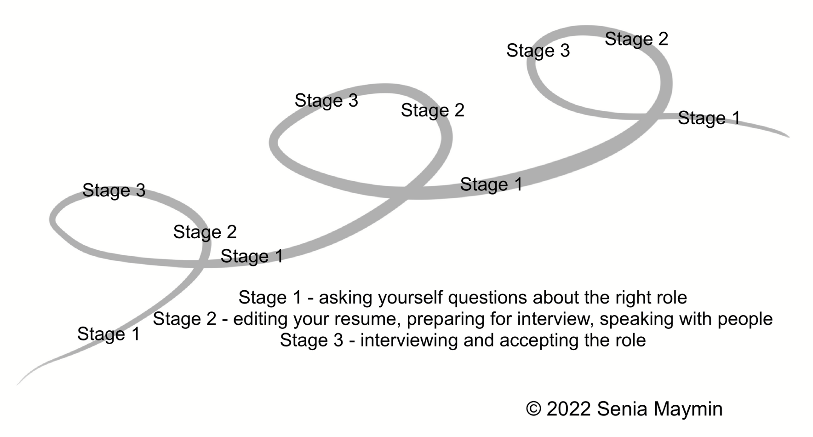

Actions:

- Health Actions
  - Sleep
  - Exercise (e.g. - 30-5-5-5-5)
  - Nutrition
  - Meditation (e.g., one minute - when waking up, when falling asleep)
- Connection Actions / Alone Actions
- Be Practical about Job-Search Actions (e.g. from someone I’m working with: an incredibly specific ANTI-mind-is-overflowing goal)

Emotions:

- It stinks, and that’s the truth, and that’s ok
- “Thanks, idea, I’ll have lunch with you on Friday”
- Something bad has happened … What’s the worst part of that? What’s the worst part of that? … How do I handle that?
- How would you talk to your friend? (We’ve ALL been in this situation - the things that stress me - Senia - out the most)
- Dancing
- Walking
- “I get you, emotion. I feel this.” - emotions only last 90 seconds

2) Plan for the work you want

Say it like, I can do all these things (that you don’t want to do), but my sweet spot is ______________ customer interviews (State what you want to do).

Growth conversations - how would you like to see me being effective in this work? What frequency would you like?

- WAY BEFORE:
  - Strengths and lesser strengths - e.g., “I’m not the best at spreadsheets…” ~ KF
  - Trainer on Tuesdays (“Am I correct to assume…?”)
  - Growth conversations - frequency, cadence
- BEFORE (I will do this after getting the offer):
  - Couple of calls, optionally “hit the ground running”
  - Whom, whom, whom - how do I reach out to them?
- WHEN STARTING:
  - 100-day-plan (as Chief People Officer, I suggested: Learn-100-Ask, e.g. listening tour) - propose a 100 day plan to the hiring manager. “I would like to do a 100 day plan”. And keep sharing this with the hiring manager.
    - 1st 3 months - learn the product, meet with people
    - Feeds the strengths discussion
    - Job crafting (I will know this as I am putting this together)*
      - WHAT
      - WHOM (“whom do I most want to work with?” Cite DPollay)
      - ON WHAT IMPACT (“what’s meaningful?”)
    - Low hanging fruit
    - What will I put on my next resume? Successes
  - The “Download” - my friend in France, me as CPO, senior leaders.
  - The “ONE THING” feedback question - early!
    - Ask the hiring manager after delivery - “What is the one thing I should do better next time”
  - The “How to Work with Me” Document
    - It can be very short - can be 3 bullets
      - Operational things
      - Things I don’t like etc…

* Job crafting - WHAT (task), WHOM (relationship), ON WHAT IMPACT (meaning)

3) Have an understanding of how someone recently found a job

Was it online or by connections?
What was it like emotionally?
What did they learn?

YOUR ACTIONS BETWEEN TODAY AND NEXT WEEK

Your Mini Challenge?

What is your ONE TAKEAWAY from today?

Three Actions - Health, Work, Connection

- Health (choose one of the below - yes, one!)
  - Your sleep action
  - Your exercise action (suggested 30-5-5-5-5)
  - Your water intake and nutrition action
  - Your mindfulness action

- Your incremental action on your job search - the mini challenge from today

- Your connection action
Who do you want to have coffee with?
Go for a walk with?

A request from me to you

I’m enjoying connecting with you in this 9-week series.
Would you be open to taking 3 minutes to write an anonymous review of how this course is going?

If so, here’s the link: https://testimonial.to/jobsearch2023

Please use your initials or firstname (or any secret name you choose). This isn’t about using your name - it’s about the content of what you say.

Much thanks!

How to Get More Info on the #JobSearch2023 Series

How to get on the mailing list - we send ALL updates here
www.jobsearch2023.com

Are the sessions recorded? Yes
www.youtube.com/@jobsearch2023
(Subscribe to get notified of the next recordings when they appear!)

Most sessions have a workbook
- Session 1 has no workbook
- Session 2 workbook - bit.ly/jobsearch2023_week2
- Session 3 workbook - bit.ly/jobsearch2023_week3
- Session 4 workbook - bit.ly/jobsearch2023_week4
- Session 5 workbook - bit.ly/jobsearch2023_week5
- Session 6 workbook - bit.ly/jobsearch2023_week6
- Session 7 workbook - bit.ly/jobsearch2023_week7
- Session 8 workbook - bit.ly/jobsearch2023_week8
- [Session 9 to be added]

